Ryan Rogers

Dr. Baylis

RF uWaves Lab

11/17/19

Post-Lab Report 8

**Summary:** This lab allows students the opportunity to put theory to practice by designing and constructing a lumped-element low pass filter (LPF) on a microstrip board, then digitally build and simulate the ideal circuit to compare the results. The circuit uses a three element design with two series inductors and one shunt capacitor. Both simulation and practical circuits demonstrated rapid drop off in power translation after the cutoff frequency of around 365 MHz.

**Discussion:** The cutoff frequency of the ideal filter is closer to 300 MHz, where the measured cutoff frequency lands at close to 365 MHz with parasitics. When compared to the complex ADS circuit, with simulated parasitics, the cutoff frequencies match more closely, both falling midway between 300 and 400 MHz with steep power drop-offs at this frequency. By shortening the distance between the shunt capacitor and the ground plane, the power of the translating signal in the stop band drops by around 10 dB, indicating the inductive behavior of the transmission lines in shunt arrangement between components boost the passing power of incident signals (I hope that wording made sense). Conventional wisdom says that adding more lumped elements to the array would boost the performance of the filter, but perhaps adjusting the lengths of the transmission lines between series components could have the same effect.

**Gallery:**

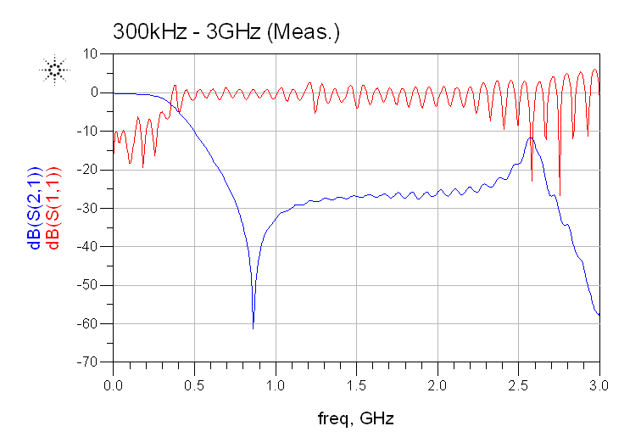

Figure : S-Parameters of Practical Circuit (Unsmoothed)

Figure 1 appears erratic because with a larger frequency band to take measurements, and only a finite number of points, fewer of those points land within the passband, causing a noticeable ripple. Figure 2 shows the same data but with more data points distributed in the passband, reducing the perceived ripple.

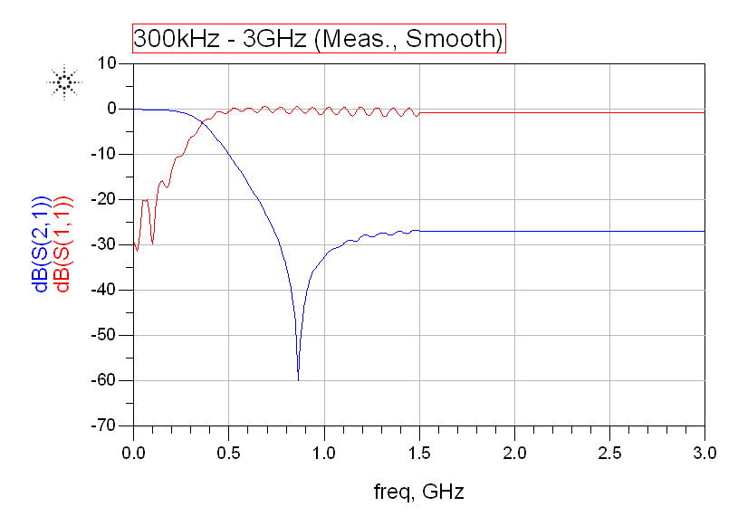

Figure : S-Parameters of Practical Circuit (Smoothed)

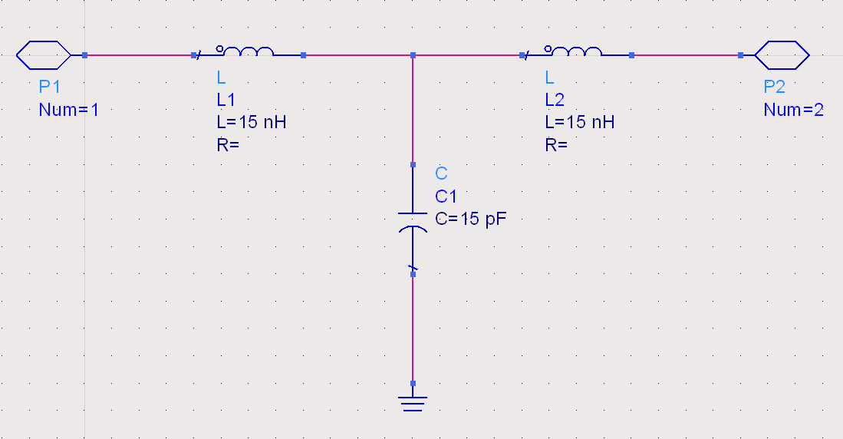

Figure : Ideal Low-pass Filter Circuit

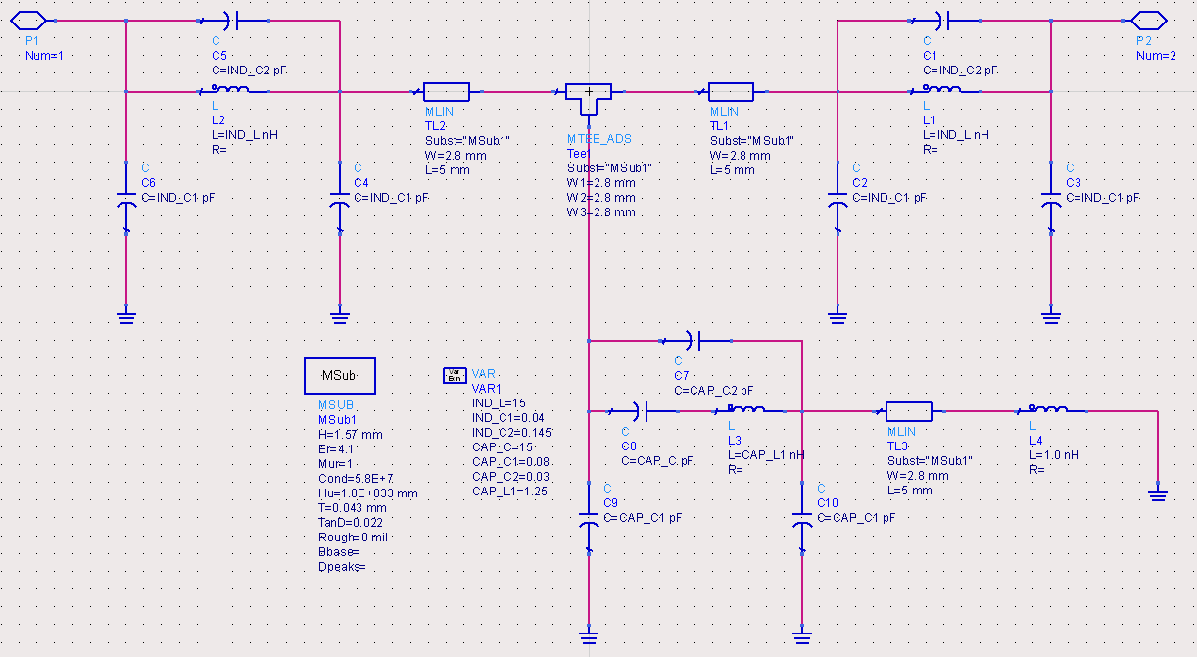

Figure : Complex Realistic LPF Circuit

Figures 3 and 4 show both versions of the LPF simulation schematic. Figure 4 includes elements to simulate practical imperfections in the circuit to yield practical behaviors during simulation. Figures 5 and 6 show the S-parameter results from simulating these two circuits.

Figure : Ideal S-Parameters

Figure : Complex S-Parameters with 6mm MLIN to GND

Figure : Complex Circuit S-Parameters with Zero Length MLIN to GND

Figure 7 shows the complex circuit with a zero-length ground connection, removing the inductive properties of that T-line. This is included to simulate the small length of wire needed to ground the shunt capacitor to the ground plane. This step is unnecessary because we used plated vias in this design, but it is good for simulation.